

**كلية تكنولوجيا المعلومات**

Faculty of IT



**GYM**

*Students:*

|  |  |
| --- | --- |
| Sdra Awameh | 202210368 |
| Rasha Alsaleh | 202210632 |

*Supervisor:*

Dr. Alaa Abuthawabeh

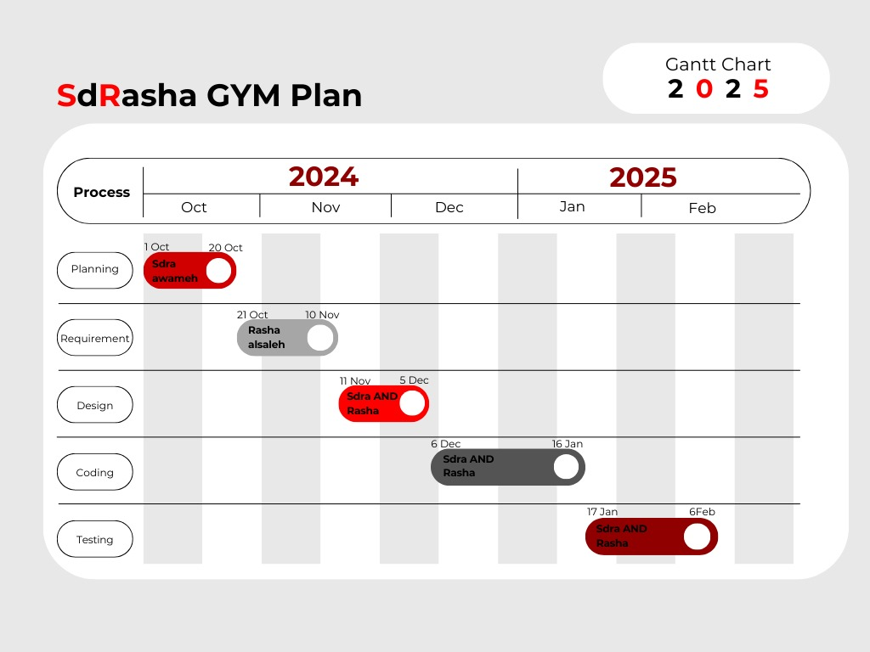*Amman – Jordan*

*2024/2025*

**Table of Contents**

1. Problem Statement and project Scope page 1

1.1 Project Plan and Schedule

2. System Analysis page 4

2.1 Functional Requirements

2.2 Use Case Diagram

3. System Design page 7

3.1 Class Diagram

3.2 EER-Diagram (if a database will be used)

3.3 Schema

3.4 User Interface

1.1 Problem Statement:

Gym owners face challenges in managing memberships, user data, and package details due to inefficient manual systems, leading to data inconsistencies, time-consuming processes, and scalability issues as their client base grows. Without a centralized digital solution, tracking active memberships, renewing packages, and maintaining accurate records becomes cumbersome and prone to errors. To address these issues, our project aims to develop a CRUD-based management system that allows gym owners to efficiently create, read, update, and delete user and package data, streamline administrative tasks, and ensure scalability for growing businesses. This system will improve operational efficiency, data accuracy, and overall member satisfaction.

The system has been facing problems due to its paper-based appointment

system. With the increase in the number of patients visiting, it has

become diﬃcult to manage the appointment system manually. Recording

of appointments and creating registers by pen and paper has become a

* 1. project Scope:

1. Package Management:

* Admin can create, update, delete, and search for gym packages.
* Track the quantity of each package.

2. Client Management:

* Admin can manage client details, including creating, updating, deleting, and searching client records.
* View active and inactive client memberships.
* Instructors can view their assigned sessions or classes.

This project aims to create a efficient, and user-friendly database system to support the daily operations of SDRASHA Gym

Project Plan and Schedule



Figure 1: This Gantt chart illustrates the timeline and sequence of activities for the project, showing the start and end dates, dependencies, and the duration of each task.

2. System Analysis

Here are some Requirements that we chose for the SDRASHA Gym

2.1 Functional Requirements

1. User Management

1.1 The system shall allow administrators to create, update, and delete user accounts (clients, instructors, admins).  
1.2 The system shall store user details, including name, date of birth, gender, email, phone number, description, and profile image.  
1.3 The system shall allow users to retrieve their account information securely.  
1.4 The system shall validate email addresses and enforce password requirements for admin accounts.

2. Package Management

2.1 The system shall allow admins to create, update, and delete packages.  
3.2 Each package shall include details such as name, image, duration, price, and description.  
3.3 The system shall allow clients to view available packages.

Use Case diagram

illustrates the interactions between actors and system functionalities

for our projectn

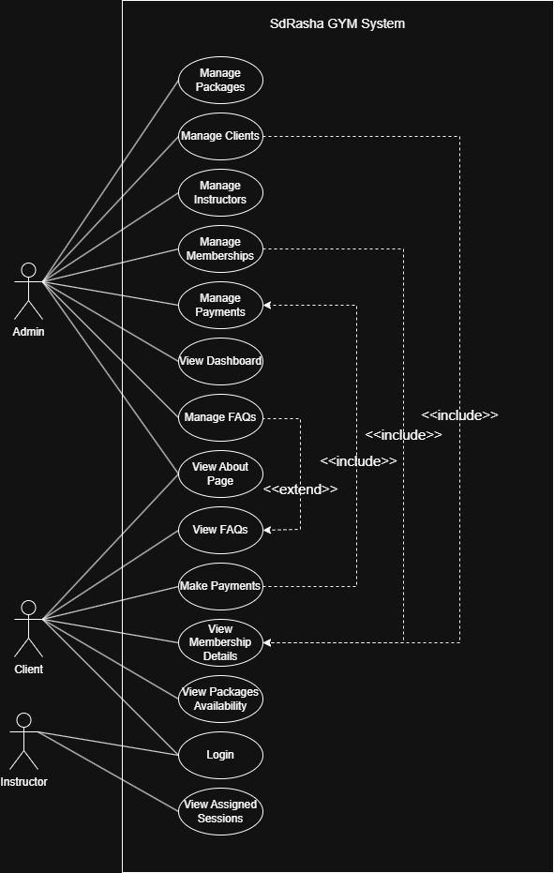

Figure 2: Use Case diagram

Class Diagram

presents our project, detailing the system's structure through classes, attributes, and their relationships.

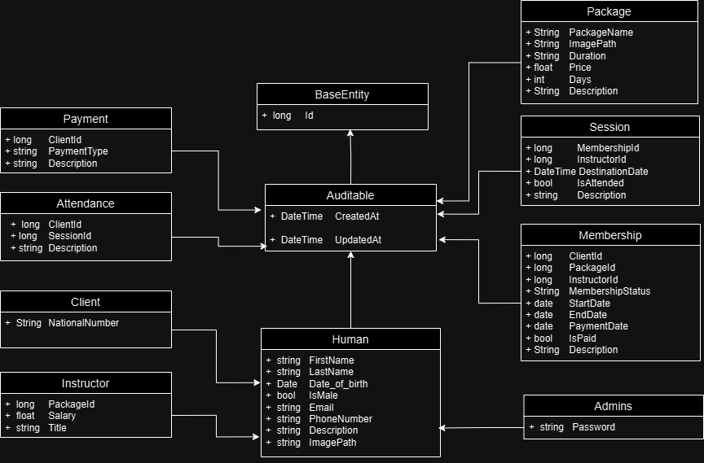

Figure 3: Class diagram of system

EER-Diagram

depicts the Enhanced Entity-Relationship (EER) diagram, illustrating the entities, relationships, and constraints within our project’s database

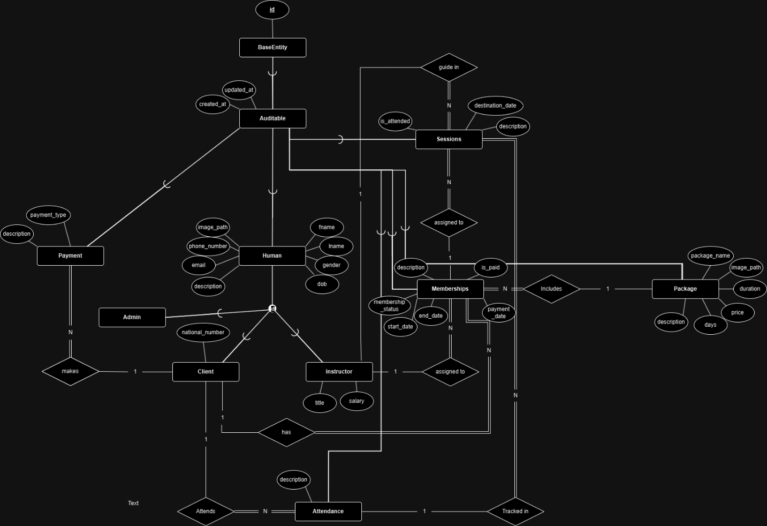

Figure 4: EER diagram of system

Schema

displays outlining the tables, their attributes, and primary relationships

within the system

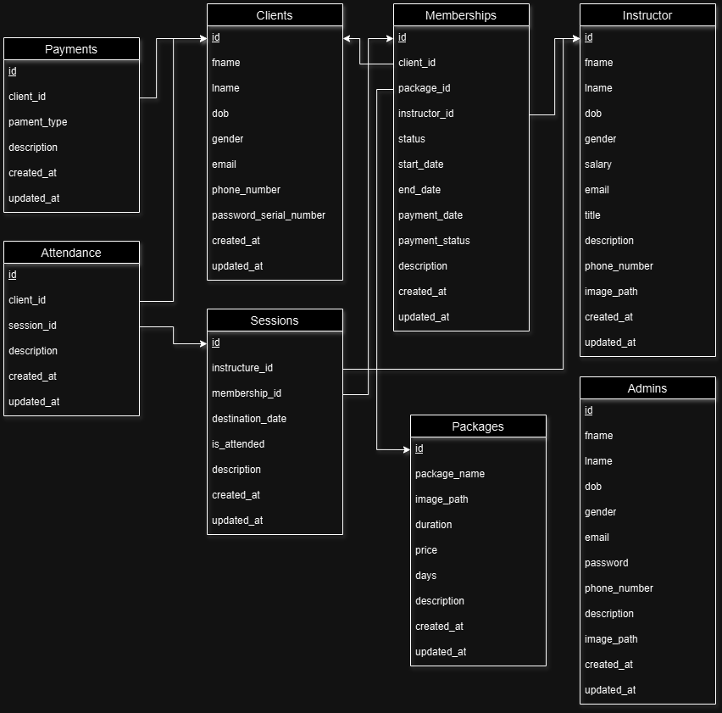

Figure 5: Database Schema

User Interface

The home page of the "SdRasha Gym Management System" provides gym owners easy access to manage users and packages. It features sections for adding/viewing users and packages with intuitive buttons. The design is visually appealing, responsive, and ensures seamless navigation for efficient operations.

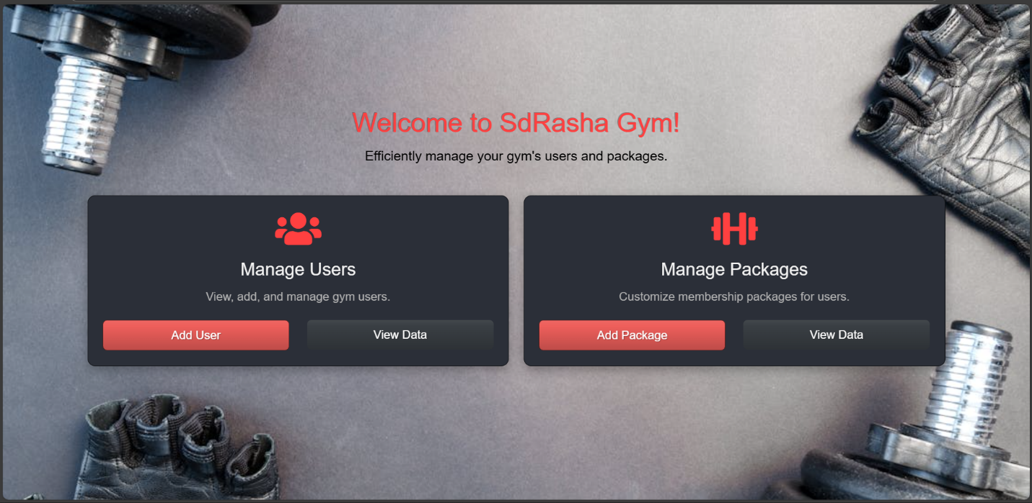

Figure 6: Home page of our project

The "Add User" registration page allows gym owners to easily input new member details. It includes fields for name, email, birth date, gender (via a drop-down list), a description, and password (with a confirmation field). This straightforward form ensures smooth data entry while maintaining security with password validation.

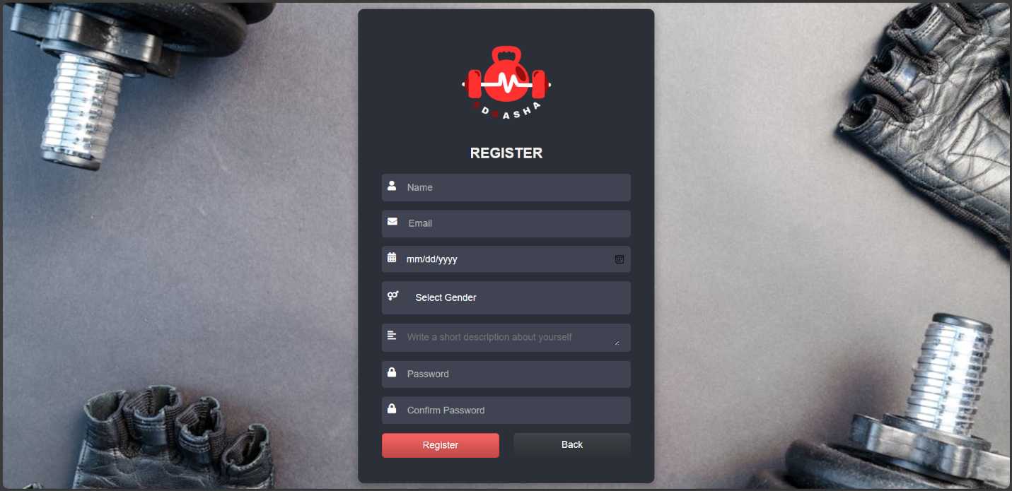

Figure 7: User registration

The "Client List" page displays all gym members in a structured table format. Each row shows the client's name, email, birth date, gender, description, and includes "Edit" and "Delete" operation buttons for easy management. This layout allows gym owners to quickly view and update client information or remove clients when necessary.

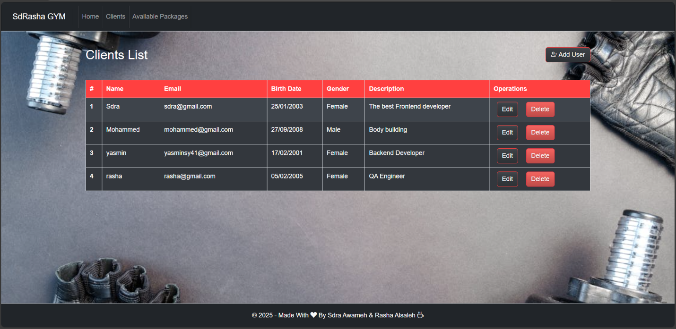

Figure 8: Client data list

The "Edit Client" page allows gym owners to update existing member details. It pre-fills the fields with the client's current information, such as name, email, birth date, gender, and description. After making the necessary changes, owners can save the updated data, ensuring the client information is accurate and up to date.

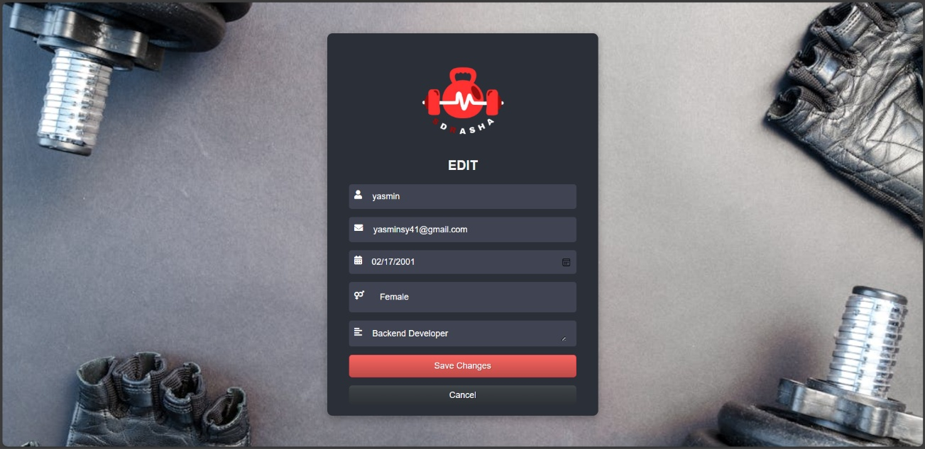

Figure 9: Edit client data

The "Delete Client" page prompts gym owners to confirm the removal of a member from the system. It displays the client's details, such as name and email, for final verification before deletion. Once confirmed, the client’s data is permanently removed from the system, ensuring a clean and up-to-date client list.

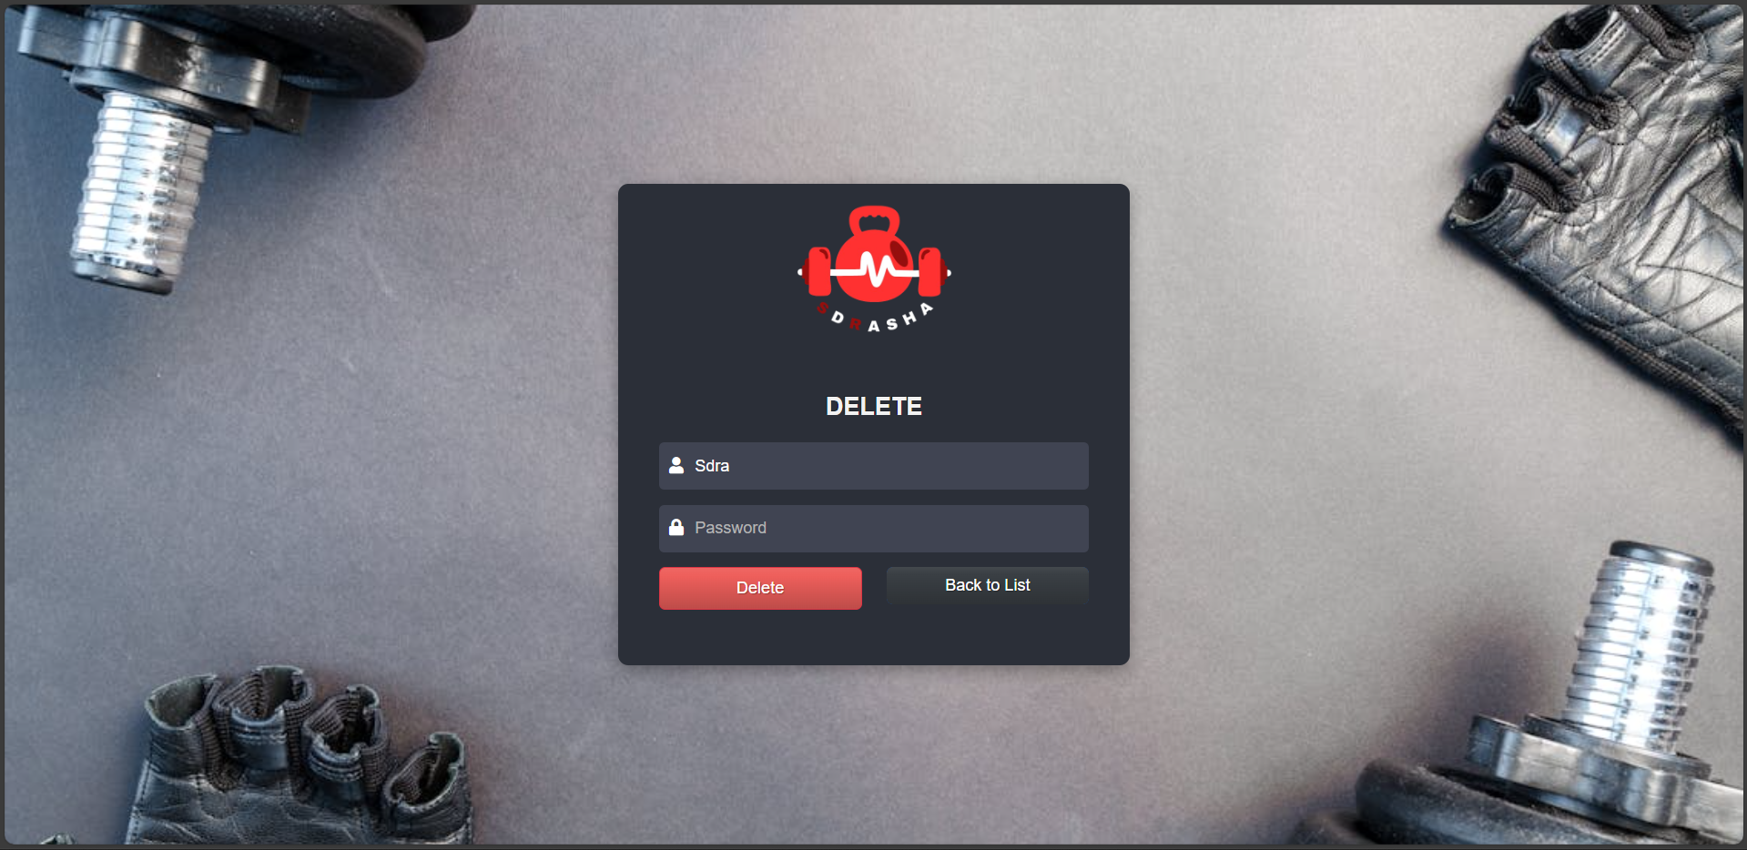

Figure 10: Delete client

The "Add Package" page allows gym owners to create new membership packages. It includes fields for the package name, duration, price, and a set of checkboxes to select available days. Additionally, there is a description field for providing further details about the package. This form helps owners easily customize and manage their gym’s membership offerings.

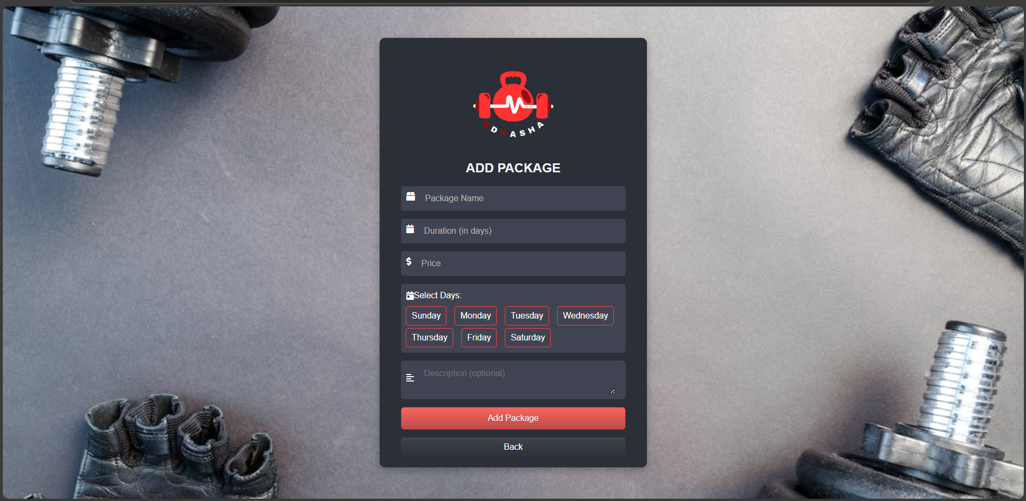

Figure 11: Add Package